Paula De Francisco Pérez  E-Commerce · Shopify & Marketplaces · Meta & Google Ads · CRM · Fashion & Beauty  Dubai, UAE | +971 50 386 3656 | paulich98@hotmail.com  linkedin.com/in/paula-de-francisco-perez-92a13119a  Portfolio: paula-de-francisco.vercel.app  Nationality: Spanish | UAE Employment Visa (employer-sponsored) | 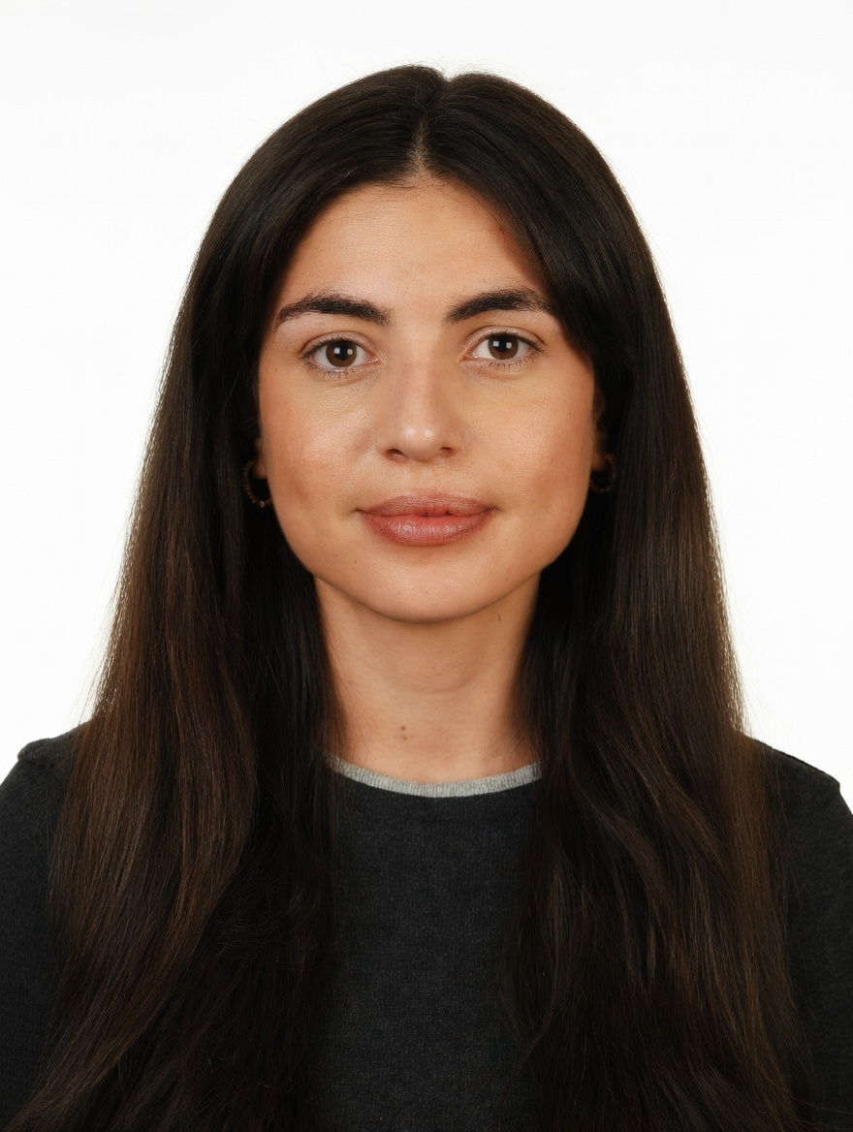
PROFESSIONAL SUMMARY

E-commerce professional with 5 years in e-commerce and commercial roles across fashion, beauty and FMCG. In Dubai I run a Shopify store end to end (orders +86%, revenue +57%), Meta and Google Ads and UAE marketplaces; at Alibaba I grew 42 fashion and beauty accounts +30% GMV QoQ.
WORK EXPERIENCE

Brand & Marketing Manager | Oct 2025 – Present
DoFreeze LLC · UAE F&B / FMCG group | Befit, Eurocake, Flair | Shopify web store + talabat, Noon, Careem, Amazon · Dubai, UAE
• Own the Shopify web store end to end: orders +86% and revenue +57% (Jun–Aug vs Q1 2026) after adding reviews, a 30-day replenishment flow and bundles rebuilt from basket analysis
• Run Meta and Google Ads on break-even ROAS per brand and channel, net of marketplace commissions, moving budget from Google to Meta; a dynamic-catalogue retargeting campaign (Advantage+) returned 3.7x ROAS in its first week
• Plan seasonal peaks (Ramadan, New Year, Fitness Month) across web, talabat, Noon and Careem, measured on incremental sales: SMASH x talabat +165% vs +4.7% control; Befit x Noon +4,176 units
• Manage creator agencies: compared four, negotiated −30% and audited their reach reports; 103 activations at AED 81 per piece
• Lead a team of two (designer, social media executive); built a Claude-based KPI-reporting system, ~40% less manual work
Key Account Manager – Beauty, Fragrances & Fashion | Nov 2023 – Oct 2025
Miravia & AliExpress (Alibaba Group) · Alibaba's e-commerce marketplaces | Beauty & Health department · Madrid, Spain
• Managed 42 fashion, beauty and fragrance accounts to +30% GMV QoQ through pricing, assortment and promotions, incl. L'Oréal Group (L'Oréal Paris, Maybelline, NYX, Redken), KIKO Milano and NIVEA (three months)
• Decided in-platform visibility (banners, placements, traffic) and owned the Flash Sales channel for Beauty, Fashion & Home, reporting to the CEO; worked with marketing, product and operations teams
• Spotted the Arabian-perfume trend and grew it into one of the fastest-growing sub-categories in Beauty & Health, onboarding 30+ stores in two months (Lattafa, Arabian Oud, Swiss Arabian, Ajmal)
Account Manager – XL Accounts | Sep 2022 – Nov 2023
Glovo · Food-delivery & quick-commerce marketplace | 10K+ employees · Madrid, Spain
• Co-managed five XL restaurant chains (incl. KFC, Taco Bell, Vicio): promotions and promo budgets, in-app visibility and its return, delivery times, cancellations and refunds
Sales Associate · Category Planning Trainee | Jun 2018 – Aug 2022
Massimo Dutti (Inditex) · Mondelez International · Premium fashion retail floor | Global FMCG category planning · Madrid, Spain
• Premium fashion on the shop floor at Massimo Dutti (styling, visual merchandising, store cadence); sell-in/sell-out and promo-effectiveness analysis at Mondelez
CORE SKILLS & TOOLS

E-Commerce | Shopify store management, merchandising, bundles, reviews, CRO, AOV, checkout, marketplaces
Acquisition & CRM | Meta Ads (Advantage+), Google Ads, SEO & AEO, email & replenishment flows, affiliates
Trading & Budget | peak-season calendars, promotions, pricing, assortment, agencies, break-even ROAS, P&L targets
Data & Reporting | revenue, orders, conversion, ROAS, uplift vs control, weekly & monthly KPI reports, Excel (Expert)
Tools & AI | Shopify, Meta Ads Manager, Google Ads, Judge.me, BixGrow, Power BI, Looker, Claude / Claude Code
EDUCATION

Bachelor's in Business Administration — CUNEF Universidad, Madrid | 2016 – 2020
Specialisation: E-Commerce · Fashion Industry · Thesis grade: 9.5/10
Google E-Commerce Certificate · Google Digital Marketing Certificate
LANGUAGES

Spanish | Native | English | Professional C1

